Full Stack Web Development

All-Recipes Lab

In this assignment, you will be given a HTML file named “index.html” along with pictures and a video. You will apply CSS styling to this page to make it better suited for reading on the web. Just like in our ASPCA website, we are creating a simplified version of a real-life website called allrecipes.com.

### Learning Objectives:

* Practice CSS styling and selectors (color, border, images, hr, and more.)
* Get practice with floats (and creating columns!)
* Use favicon icon for the first time
* Practice using pseudo classes and pseudo elements

Once the CSS styling is applied, your website should look *something* like this:

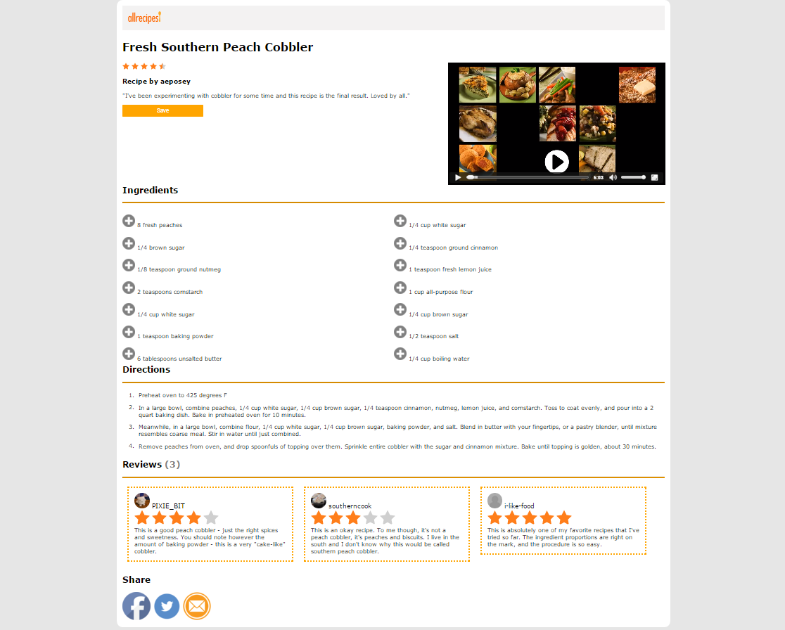

*Website as zoomed out from 50% view:*

# HTML

Before we get started on styling our web page there are a few things we need to do!

1. Validation: Run index.html through the w3c validation checker. It *must pass* the w3c validation checker before you move on to the next steps.
2. Folder structure: Move all of your images to an appropriate “images” folder. Move the video to an appropriate “videos” folder. Now you must fix the broken links on your index.html page.
3. Favicon: Now, you will add a “favicon” image to your web page.

A “**favicon**” is an icon associated with a URL that is displayed in a browser's address bar or next to the site name in a bookmark list. See examples below:

Screenshot 2017-07-31 00.31.21.png

To add a favicon image to your site add the following text to the <head> section of your HTML page:

<link rel="icon" type="image/png" href="images/favicon.png" />

You should see an orange logo pop up next to your web page’s “title” in your browser tab.



# CSS

Time to style our page! Be aware that only some of the essential CSS styling is listed below. Look closely at the screenshot of the page to match the website as closely as you can. Some things such as padding or margins may not be listed.

**Body:**

* Body should take up less than 100% of the screen’s width.
* Body content should be centered horizontally on the page.
* Font of the website is “Verdana.”
* Background color of the page is “#e6e6e6”

**#recipe, #about**

* Should both be floating left.
* #about section should have a width of 60%;

**#main_content**

* Background color must be white

**Video:**

* Video should be floated left with a width of 40%

**Header:**

* Background color is: rgba(226, 225, 225, 0.42)

**Horizontal rules:**

* Border-color:orange;

**Unordered list:**

**Do these steps in order to see the changes as they come!**

1. The list item’s widths should be 50%
2. Content is floated left
   1. **Steps 1+2 should create a two column unordered list! Pretty cool, eh?**
3. Now, we will replace the list item bullets with an image. To do this, we will use what’s called a “pseudo-element.” In this case, we will use the “:before” pseudo element. Add the following to your CSS:

ul li:before{

content: url(‘../images/plus-icon.png’);

}

4. Now, to remove the (now unnecessary) bullets make the entire unordered list’s list-style:none;

5. Let’s add some pizzaz! When each individual ingredient is hovered over, make the background color: rgba(255, 165, 0, 0.39). (Finding the correct CSS selector for this may be tricky!)

**Save button:**

1. Resize the Save button to be larger.
2. Change the background color to orange and the font color to white.
3. Let’s slightly “round out” the corners and take away the border. To do this add the following CSS styling to your save button:

border-radius: 2%;

border-width: 0;

4. Add a hover “action” to your Save button by using the “hover” pseudo class. The Save button’s color should change to rgba(255, 165, 0, 0.39) when hovered over with the computer mouse.

**Share section:**

* Images must be resized

**Reviews (#one, #two, #three)**

* Must all be floating left. Adjust their widths accordingly.
* Images must be resized.
  + See border-radius attribute for how to turn images into circular images! :)
* Each individual review must have a “dotted” border style of color “orange.” You must adjust border-width to be 5px.
* **\*Editing of the HTML:\*** Bringing the star reviews down to their own lines:
  + Add a <div> tag with class value of “star-reviews” around **each section** ofstars. This will bring the stars down to their own line as they will be treated as block elements.

**#number-reviews span**

* Font color should be grey.